**HOTEL BOOKING APP**

|  |  |
| --- | --- |
| TEAM MEMBERS | ROLL NO |
| ASHUTOSH KERKAR | 117 |
| AISHWARYA KERKAR | 118 |
| SIDDESH WAYKAR | 119 |
| TUSHAR KOLI | 123 |

The Hotel Booking System is a web-based  desktop application that allows users to search for hotels, check availability, and book rooms online. The system streamlines the process for both customers and hotel administrators the "Hotel Booking Logic Django" project! This dynamic website is designed to implement room booking logic and provide a user-friendly interface for managing reservations. The project is built with Django, a powerful web framework, and is hosted on Render for easy access.

## **About This Project**

The "Hotel Booking Django" project is a web-based room reservation system. It offers the following features:

🛌 ****Room Booking****: Users can explore available rooms, check availability, and make reservations.

🗓️ ****Booking Logic****: The project includes room booking logic that manages room availability and prevents overbooking.

🏢 ****Admin Portal****: Access the admin portal to manage rooms, reservations, and user data.

🔑 ****User Authentication****: Users can create accounts and log in to make reservations.

💼 ****Admin Controls****: Admins can add and manage rooms, review reservations, and monitor user activity.

**TECHNOLOGIES USED**

FRONTEND HTML,CSS

BACKEND DJANGO FRAMEWORK

DATABASE SQLite

VS Code for development

## Languages PYTHON

HTML (HyperText Markup Language) is the standard language used to **create and structure content on the web**. It tells the browser how to display **text, images, links, forms, videos**, and other elements on a webpage.

**CSS (Cascading Style Sheets)** is used to **style** and **layout HTML elements** on a webpage. It controls the **look and feel** of your site—like colors, fonts, spacing, positioning, and responsiveness.

Django is a high-level, open-source web framework written in Python that allows developers to build secure and maintainable websites quickly. It follows the Model-View-Template (MVT) architecture

MAIN FEATURES

**User Registration/Login**​

**Hotel Search & Filter** (by location, date, rating, price, etc.)​

**Room Availability Check**​

**Online Booking & Cancellation**​

**Admin Dashboard** for managing bookings, rooms, users, and reports

​

VIDEO REFERENCE

<https://youtu.be/OTmQOjsl0eg?si=Sk-ZQagI-7hgCgfM>

TELUSKO

<https://youtu.be/JxzZxdht-XY?si=Fk5XURmrjYZNlLCS>

CODEWITHHARRY

GITHUB CODE

<https://github.com/AshutoshKerkar/hotel-booking-django>

PROJECT PLANNING HOW IT STARTED

First our group watch videos of django to start the project

Then we got the idea of hotel booking app

First we install cs code in our system

Then download python latest version

Now open command prompt

And type pip intall virtalenvwrapper-win it will download file

Then type mkvirtualenv test it will create a folder

Then we have to type pip install django to install django

To start the project make we have create a folder mkdir project

,cd project and to start the project type in cmd django admin startproject hotel booking it will create a hotel booking folder

In that folder we get our django file like init,setting urls files to perform our project

Now openvs code and open the folder of hotel booking

There we get or manage.py files and more files like admin.py,model.py,view.py

We start our project with index page with the help of html and css and then creted hotelpage login and sigin , sigup page

Then we added images to page OF INDEX ,SIGIN ,SIGUP

FOR THE DATABASE WE USE SQLite

To add database we have to open our hotel folder and in that we have to open settings.py

Scrool down and have to change the database engine sqlite

Create a database file in sqlite folder with the name and give password to the database

In django we have to migrate the database to sqlite

For django admin we have to simple type in terminal

Python manage.py createsuperuser it will ask for name and password type Ashutosh password any you want after that open our website and open admin panelby coyp the link of the website and type admin at the end of the website it will open django administration

Type the user name and password it will open admin page

To simple open the project

Navigate to the project directory:

cd hotel-booking-django

Install the required Python packages:

Pip install -r requirements.txt

Apply database migrations:

*Python manage.py migrate*

Create a superuser for the django admin portal:

Python manage.py createsuperuser

Start the development server:

Python manage.py runserver

To open admin panel 127.0.01:8000/admin/

The project will start

In our hotel app we can sigin sigout

To sign in we have to first sig up type our email username and password then the user is created

Then we have to sign in we that name

Now we can book hotel room

We have to just click the photo of the hotel we can see the price of the hotel description and also book the room when we have to check in and check out selectin date and just have to click book now it will show our room has booked successfully

Now open the admin panel

Here we can add user delete the user the admin has full power

We can also add hotel room just click on add hotel

Then type hotel name, hotel price ,desription, amenities just select ctrl and select the amenites you want to add ,room count

And then select save and continue

To add imagess to the hotel click on hotel imagess select the hotel we have created and add imagess to the folder then click save it will add new hotel room with desription and price

Images :

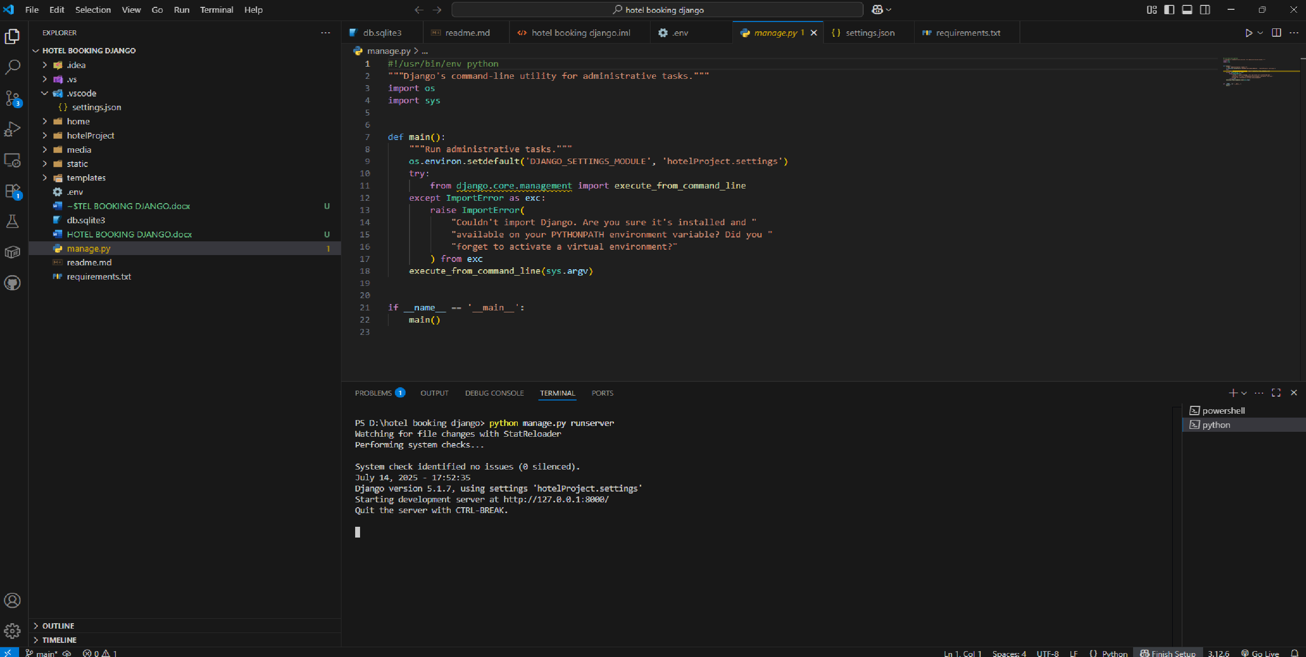

WEBSITE:

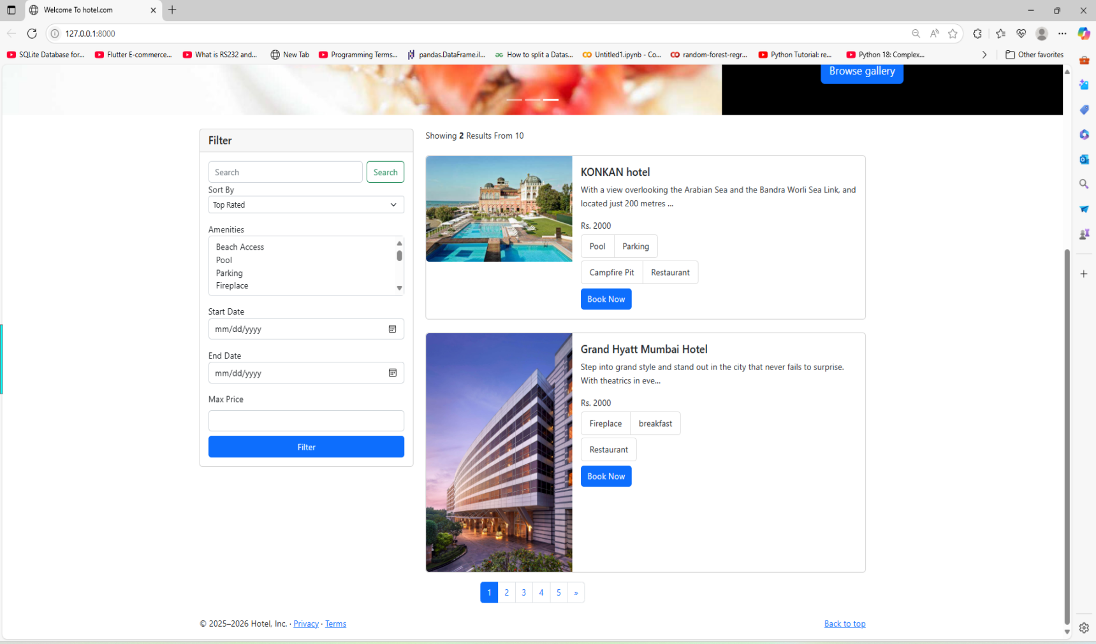

Sigin up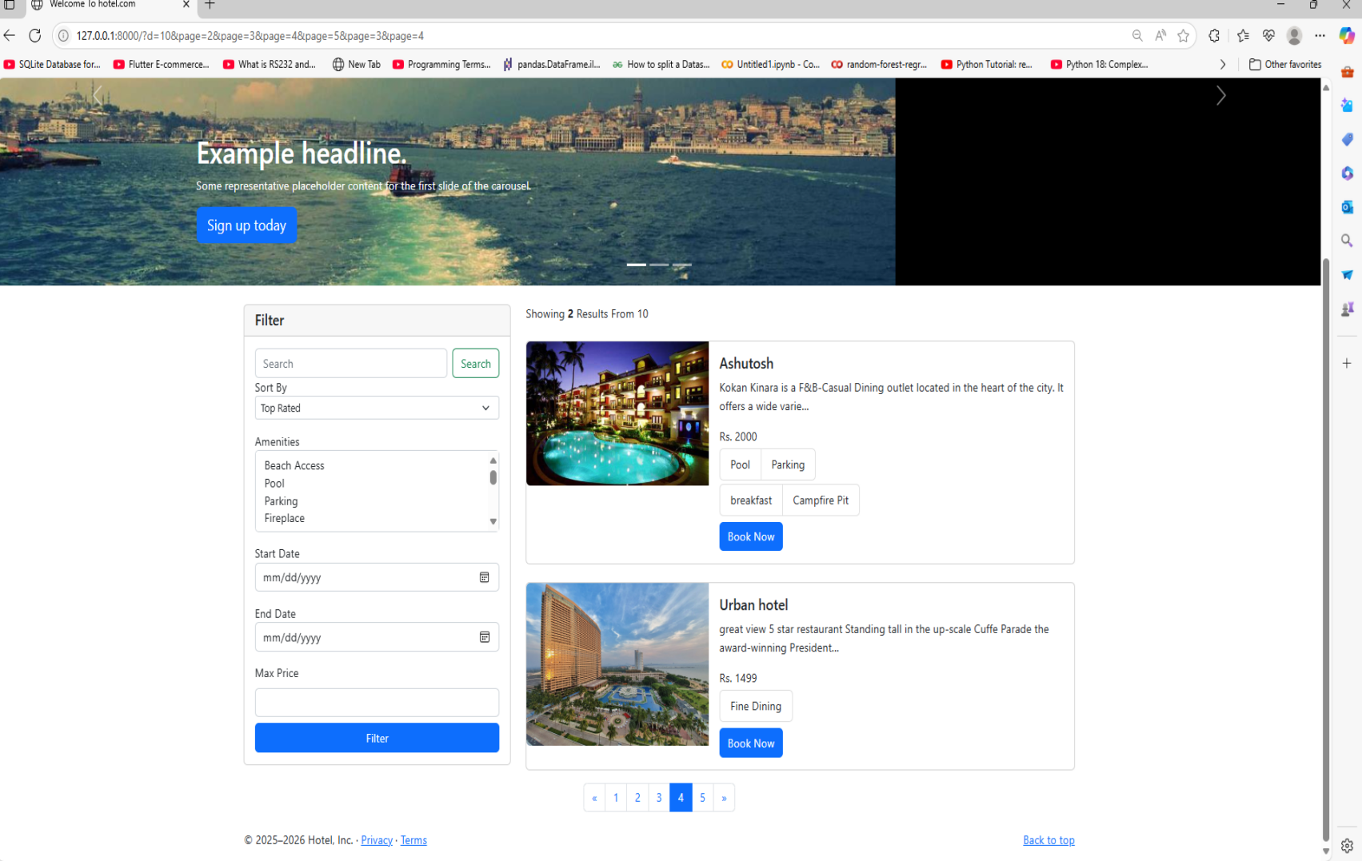

Admin page:

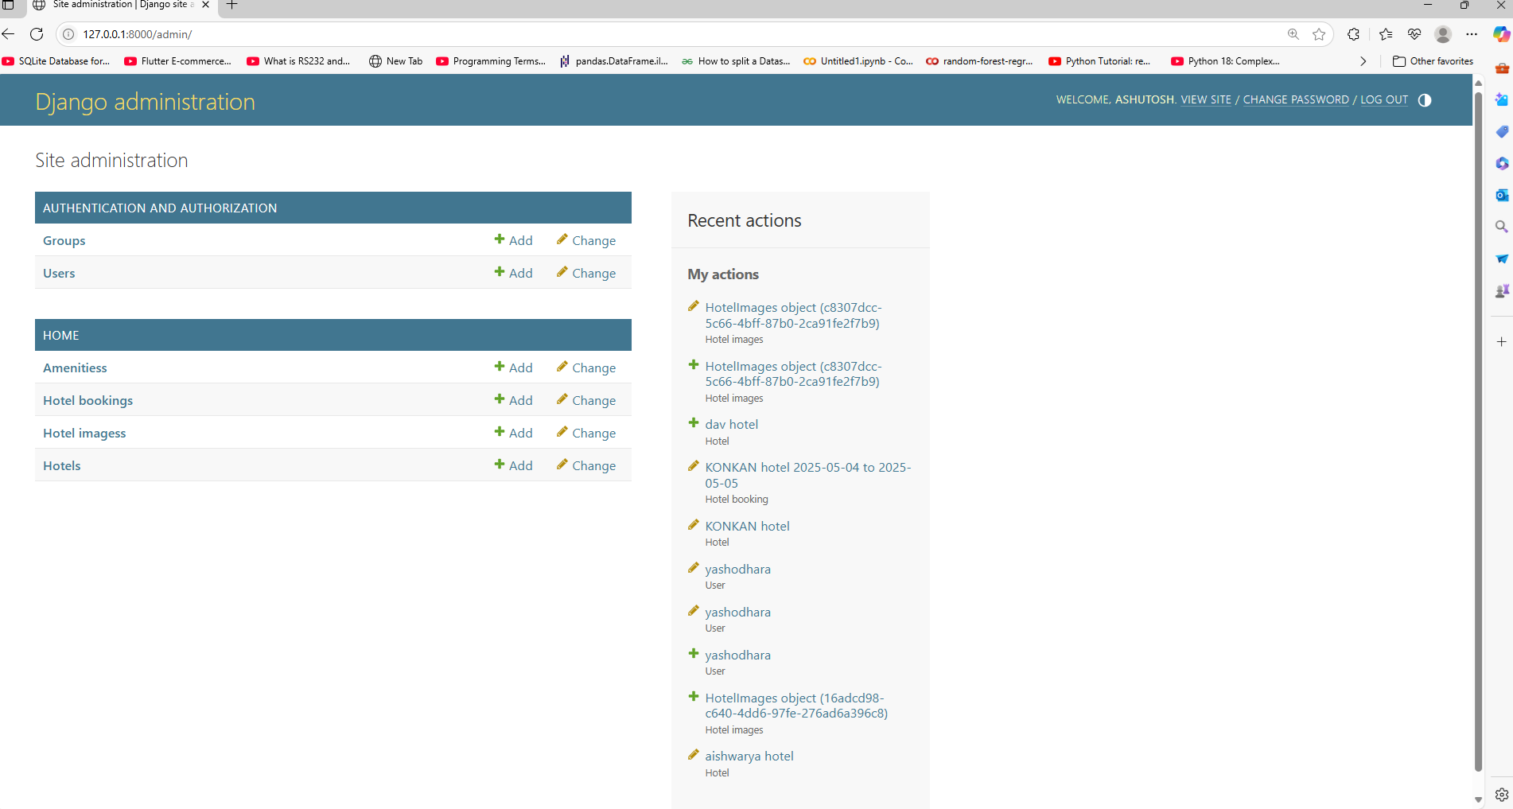

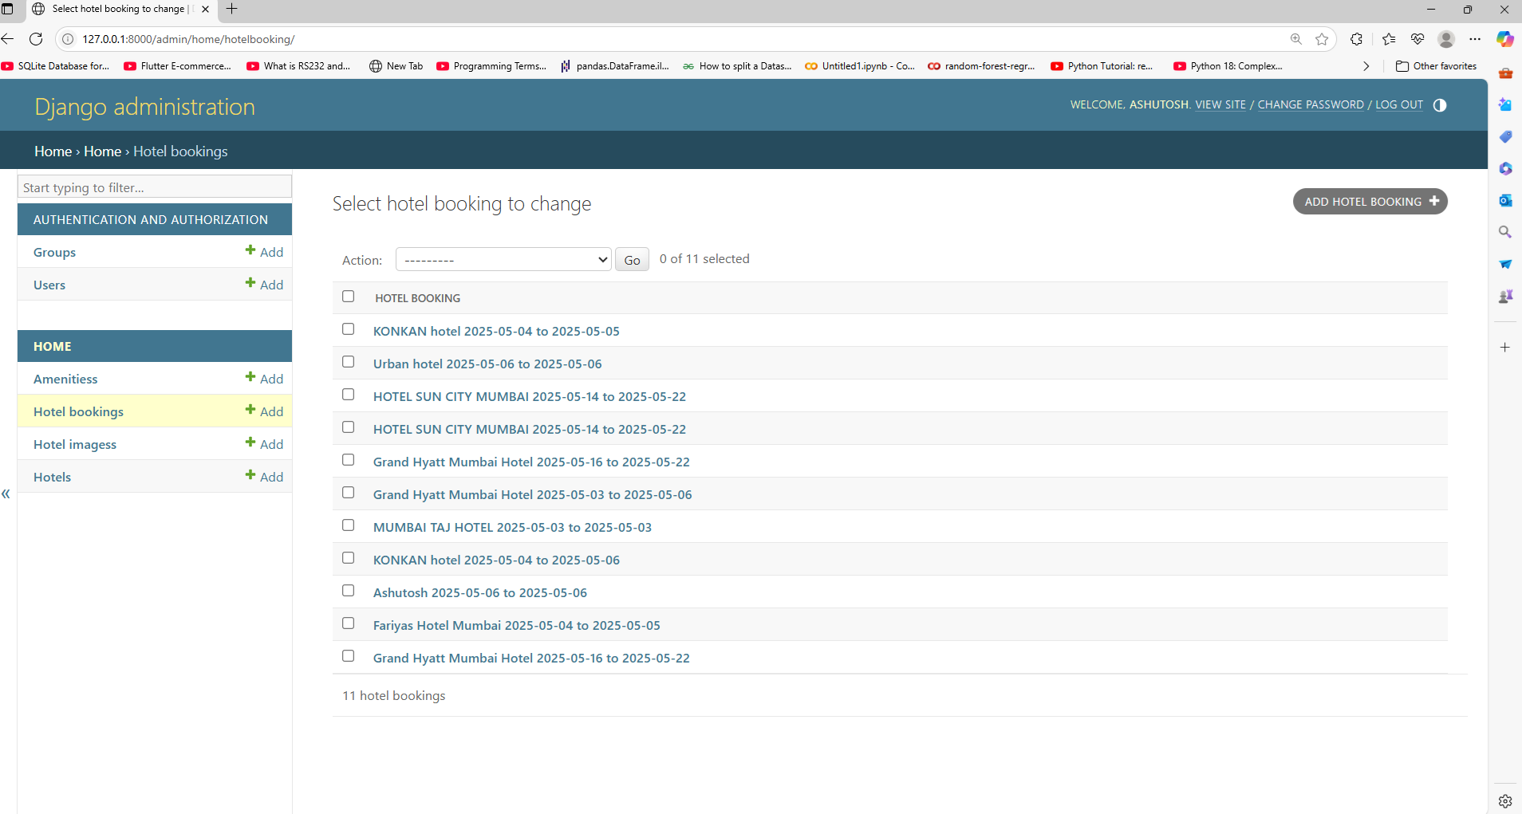

BOOKING ROOM SUCCESSFULLY:

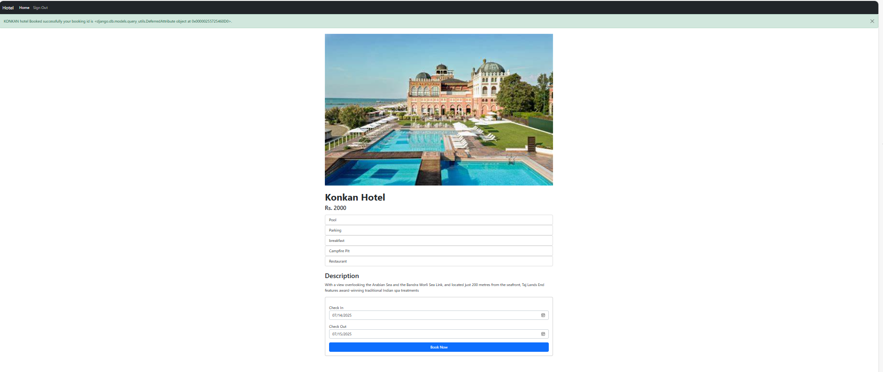

GITHUB LINK:

<https://github.com/AshutoshKerkar/hotel-booking-django>